**Postgresql (psql)**

* Difference between psql and sql:

| **Psql** | **Sql** |
| --- | --- |
| Psql is a command line tool Postgresql an advanced open-source relational database system. | Sql is a standardized language used to interact with relational database system. |
| Used specific for PostgreSQL database. It’s support sql queries and additional commands unique to PostgreSQL. | Used in any relational database management system, example: MySQL, PostgreSQL, SQL Server etc. |
| Psql is not a universal standard it’s use in only PostgreSQL. | SQL is a universal standard and it’s syntax is supported across multiple database management system. |
| Psql is a PostgreSQL specific command-line tool to interact with PostgreSQL databases using sql and additional commands. | Sql is the language used for querying and managing relational databases. |

* Create/Delete Multiple Database:

-First I create test database using **createdb test2;** command.

-Delete that test database using **dropdb test2;** command.

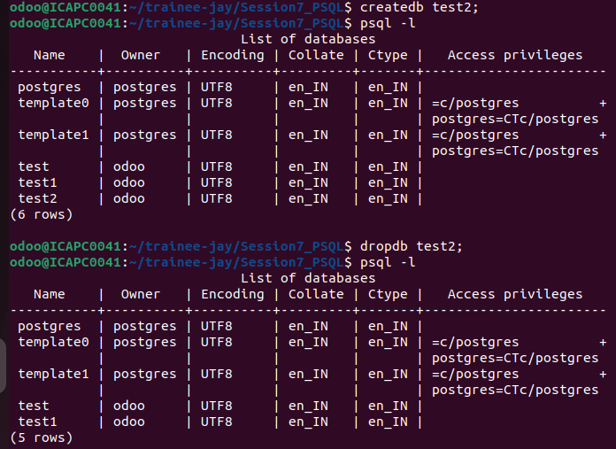

* Insert data into Tables:

-I create a test database and in that test database i create one table student. And insert some rows to that table student.

-using insert query to insert multiple data and give input as column wise.

example:



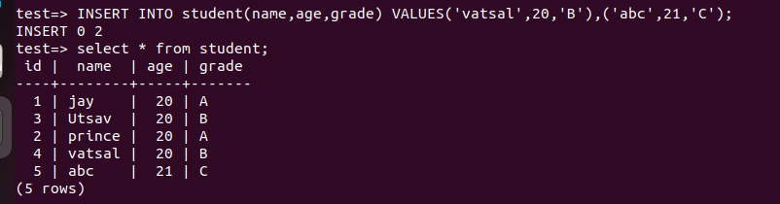

* Alter Command for Tables:

-Using the Alter command we add, delete and modify the column and also we update the data type of column using the alter command.

ADD column:

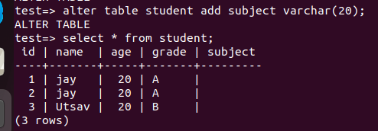

DELETE column:

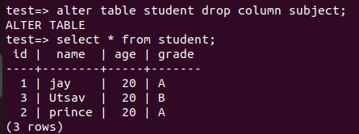

Modify DataType:



Update Table:

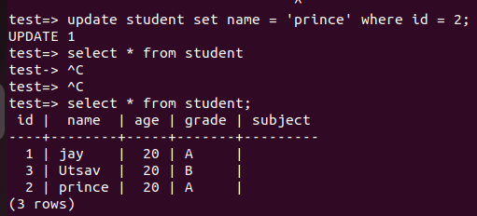

* Task Output ScreenShot:

